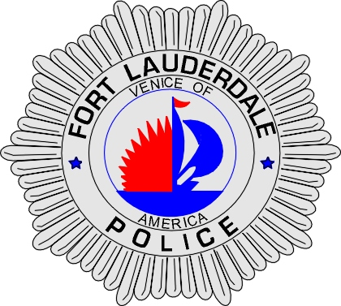 | CITY OF  FORT LAUDERDALE  POLICE DEPARTMENT  PRESS RELEASE
Detective Travis Mandell  Public Information Office  (954) 828-6433  tmandell@fortlauderdale.gov | CITY OF  FORT LAUDERDALE  POLICE DEPARTMENT  PRESS RELEASE | December 13, 2010
 | ACCIDENTAL DEATH

The Fort Lauderdale Police is currently investigating an incident where two males fell from a bridge on Saturday, December 11, 2010 at approximately 1:45 A.M. The initial incident took place at 320 Southwest 2 Avenue, on the railway bridge that runs over the New River.

The Police Department received a telephone call from a person in the area saying that two males had just fallen off the train bridge as it was rising up into the air. Patrol Officers responded to the scene, as well as personnel from the Fort Lauderdale Fire Rescue Department. Initially, Officers were only able to locate one male, Joe Cundall, who landed on the railroad tracks on the north bank of the river.

The Fort Lauderdale Fire Department utilized a search and rescue vessel in order to locate the other male who had fallen off the bridge and possibly into the New River. The Fire Department located the other male, identified as Kyle Conrad, in the waterway at approximately 2:23 A.M.

Both males were transported to Broward General Hospital. Conrad later succumbed at the hospital to the injuries he sustained from the incident. Conrad was pronounced deceased at approximately 1:28 P.M on December 11, 2010.

Preliminary investigation has revealed that Conrad and Cundall were out at the Riverfront Entertainment Complex, when they decided to find other establishments on the south side of the river. Conrad and Cundall attempted to cross the river, by walking on the automatically controlled train bridge. The bridge is programmed to remain in the up position, unless a train is headed towards the bridge, at which point it lowers so the train can cross the New River.

As Conrad and Cundall were crossing the bridge, it began to rise back into the up position. Conrad and Cundall attempted to get off the bridge, but only Cundall was able to make it back to the tracks on solid ground. Conrad fell into the New River after striking his head on the way down into the river.

The Broward County Medical Examiner has ruled the manner of death as an accident.

###

