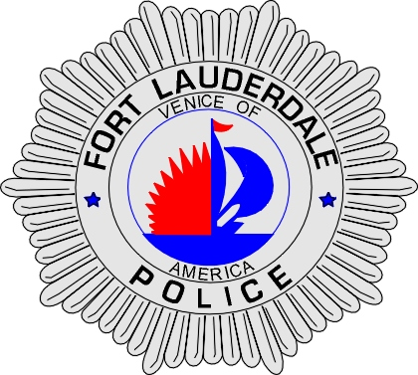 | CITY OF  FORT LAUDERDALE  POLICE DEPARTMENT  PRESS RELEASE
Detective Travis Mandell  Public Information Office  (954) 828-6433  tmandell@fortlauderdale.gov | CITY OF  FORT LAUDERDALE  POLICE DEPARTMENT  PRESS RELEASE | December 1, 2010
 | SEXUAL BATTERY

The Fort Lauderdale Police is currently investigating a sexual battery that took place in the city of Fort Lauderdale on November 12th, 2010, at approximately 9:22 P.M. The sexual battery took place in the area of North Dixie Highway.

Investigators have drafted a sketch of a person of interest as seen in the picture below. Investigators are requesting the help of the public in identifying this person of interest involved in the case.

Anyone with possible information regarding the identity of this person of interest is asked to call Broward County Crime Stoppers at 954-493-TIPS or contact Detective Cahir at 954-828-5964.

###

