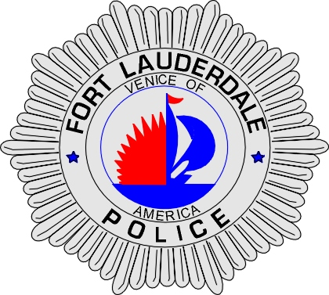 | CITY OF  FORT LAUDERDALE  POLICE DEPARTMENT  PRESS RELEASE
Detective Travis Mandell  Public Information Office  (954) 828-6433  tmandell@fortlauderdale.gov | CITY OF  FORT LAUDERDALE  POLICE DEPARTMENT  PRESS RELEASE | November 23, 2010
 | WALGREENS ARMED ROBBERY
***VIDEO IS AVAILABLE***

The Fort Lauderdale Police Department is investigating an armed robbery that occurred on Saturday, November 11, 2010 at approximately 2:35 A.M. The robbery took place at the Walgreens store located at 2355 Northeast 26 street.

Sayyah Hassan, a store employee, called the police advising that he had just been held-up at the store while he was working. Hassan told police that while he was working in one of the store isles, a black male wearing a mask entered into the store armed with a silver hand gun. The black male approached Hassan and shoved the gun into Hassan’s midsection, telling him to open a cash register. As Hassan walked with the black male to the cash register, the black male told Hassan “I’ll shoot you.” In fear for his safety and life, Hassan opened the cash register and the black male then began rifling through the register drawer, removing all of the cash. The black male then fled the store in an unknown direction with the money still in his possession. The loss was approximately $470.00 in US Currency.

Fort Lauderdale Police officers established a perimeter and apprehension K-9 officers were summoned to the scene, but the black male was unable to be located.

Anyone with information or who may have witnessed this robbery is encouraged to contact Detective Orlando Almanzar at 954-828-5546 or Broward County Crime Stoppers at 954-493-TIPS.

###

