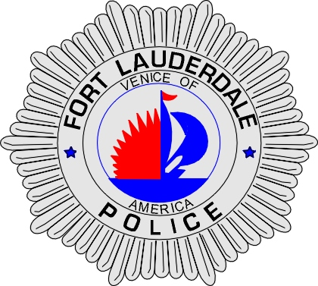 | CITY OF  FORT LAUDERDALE  POLICE DEPARTMENT  PRESS RELEASE
Detective Travis Mandell  Public Information Office  (954) 828-6433  tmandell@fortlauderdale.gov | CITY OF  FORT LAUDERDALE  POLICE DEPARTMENT  PRESS RELEASE | November 17, 2010
 | ARSON

On November 16, 2010 at approximately 10:24 P.M., the Fort Lauderdale Fire Department responded to a report of a structure fire. The fire was reported at the Galleria Mall located at 2414 East Sunrise Boulevard. Prior to the Fire Department’s arrival, the fire suppression sprinkler system was activated and the flames were extinguished.

It was later learned that several employees had heard the fire alarm sounding and located the fire. Those same employees then attempted to extinguish the flames, but were unable to do so.

The initial investigation has revealed that trash from a retail outlet was set on fire in a back corridor of the Galleria Mall, behind several of the stores. Evidence located on scene indicates that the fire was intentionally set.

There was minimal property damage due to the fire.

If anyone has additional information regarding this arson, please contact Detective Gauntner at (954)-828-5527 or Broward County Crime Stoppers at 954-493-TIPS.

###

