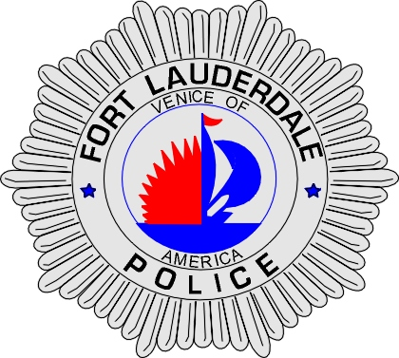 | CITY OF  FORT LAUDERDALE  POLICE DEPARTMENT  PRESS RELEASE
Sergeant Frank Sousa  Public Information Office  (954) 828-6433  FSousa@fortlauderdale.gov | CITY OF  FORT LAUDERDALE  POLICE DEPARTMENT  PRESS RELEASE | October 21, 2010
 | CHILD PORNOGRAPHY ARREST

The Fort Lauderdale Police Department in conjunction with the South Florida Internet Crimes Against Children (ICAC) Task Force executed a search warrant on Thursday, October 20th, 2010. Members of the Task Force include the Fort Lauderdale Police Department, Broward Sheriff’s Office, U.S. Immigrations and Customs Enforcement (ICE), and the Attorney General’s Office.

Detectives from the Fort Lauderdale Police Department located an IP address during an undercover internet investigation that was sharing child pornography. The investigation revealed that the IP address was located at 609 SW 14 Avenue, Apartment A.

Fort Lauderdale Detectives and members of ICAC Task Force executed a search warrant at the above mentioned residence. The warrant yielded eight videos of children engaged in sexual acts. The children depicted in these videos ranged from 8 to 13 years of age.

Mark Tierney, W/M, 5/19/1955 was arrested and charged with eight (8) counts of Possession of Child Pornography. Tierney was also charged with a narcotics violation. Post Miranda, Tierney confessed to both searching for and downloading child pornography files via the internet.

If anyone has any information regarding this incident they are encouraged to contact Detective Rob Mauro at 954-888-1570 or Broward County Crime Stoppers at 954-493-TIPS.


###

