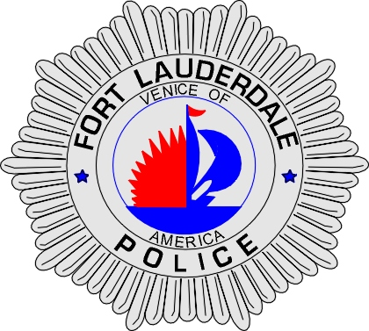 | CITY OF  FORT LAUDERDALE  POLICE DEPARTMENT  PRESS RELEASE
Sergeant Frank Sousa  Public Information Office  (954) 828-6433  FSousa@fortlauderdale.gov | CITY OF  FORT LAUDERDALE  POLICE DEPARTMENT  PRESS RELEASE | October 18, 2010
 | ARMED ROBBERY
**Video Surveillance is Available**

The Fort Lauderdale Police Department is investigating an armed robbery that occurred on October 11th, 2010 at approximately 7:40 P.M. The robbery took place at Nine to Five Import Export located at 1811 Northwest 51 Street.

Investigation has revealed that the manager of the business was approached by an armed black male, who was wearing all black clothing. The suspect demanded money from the manager. The manager initially resisted the suspect’s demands. When the manager did this, the suspect struck the manager in his forehead with the handgun.

Fearing for his life, the manager opened the safe. The suspect then began tying up the victim with tape. The suspect took cash and checks from the safe. The suspect was also seen taking a box, which contained a computer. The suspect then fled the business in an unknown direction. The loss of the robbery was approximately $4,800.00.

The suspect was described as a B/M; 6’0”; Approximately 180 pounds; armed with a semi-automatic handgun. He was last seen wearing all black clothing, a black mask, and white gloves.

Anyone with information regarding this robbery is encouraged to contact Detective Richard Rivera at 954-828-6355 or Broward County Crime Stoppers at 954-493-TIPS.

###

