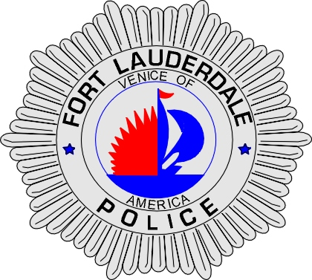 | CITY OF  FORT LAUDERDALE  POLICE DEPARTMENT  PRESS RELEASE
Sergeant Frank Sousa  Public Information Office  (954) 828-6433  FSousa@fortlauderdale.gov | CITY OF  FORT LAUDERDALE  POLICE DEPARTMENT  PRESS RELEASE | October 13, 2010
 | SHOOTING

Update:
Jesnishia Orozco has passed away at Broward General Medical Center as a result of the injuries she suffered. Detectives have learned from witness statements that Juan shot his sister. However, this is preliminary and the investigation will continue until the Medical Examiner officially confirms the manner of death.

Release:
The Fort Lauderdale Police Department is investigating a shooting that occurred today at approximately 1:22 P.M. The shooting took place at Beach Place located at 17 South Atlantic Boulevard.

Preliminary investigation has revealed that a brother and sister were on the first level of Beach Place visiting their mother, who worked at a cigar stand. The two were discussing money and living arrangements. The mother turned away from her children at this time and heard several gunshots. When she turned around she observed her daughter and son lying on the ground.

Fort Lauderdale Fire and Police Personnel immediately arrived on scene and began treatment of both individuals. Fort Lauderdale Fire Rescue transported both the female and the male to Broward General Medical Center. The male passed away a short time after arriving at the hospital from his injuries. The female is currently listed in critical condition.

The male has been identified as Juan Alicea Orozco, 9-13-1987 and the female has been identified as Jesnishia Alicea Orozco, 7-2-1985.

Anyone with information regarding this incident is encouraged to contact Detective William Dejesus at 954-828-5366 or Broward County Crime Stoppers at 954-493-TIPS.

###

