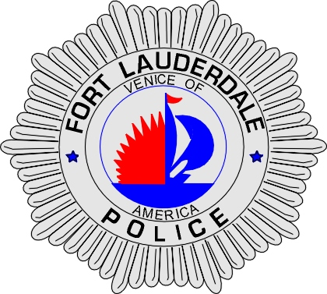 | CITY OF  FORT LAUDERDALE  POLICE DEPARTMENT  PRESS RELEASE
Sergeant Frank Sousa  Public Information Office  (954) 828-6433  FSousa@fortlauderdale.gov | CITY OF  FORT LAUDERDALE  POLICE DEPARTMENT  PRESS RELEASE | October 14, 2010
 | CVS ROBBERY
**Surveillance Video is Available**

The Fort Lauderdale Police Department is investigating an armed robbery that occurred on October 10, 2010 at approximately 10:11 P.M. The robbery took place at the CVS Pharmacy located at 3501 West Davie Boulevard.

Detectives have learned through their initial investigation that the suspect was inside of the CVS store for approximately 10 minutes before he approached the front counter. After 10 minutes, the suspect approached the front counter where the cash register was located. The suspect then lifted his shirt and displayed the handle of a gun to the cashier. The suspect ordered the cashier to empty the contents of the cash register. In fear for her life, the cashier emptied the cash inside of a white CVS bag.

Once the suspect had the bag, he ordered the cashier to come out from behind the register. The suspect then directed the store employees towards the office. The suspect demanded that the employees open the office and provide him the cash from the cash drop box. The victims complied and placed that currency inside of a Bank of America bag.

The suspect then pulled a long rifle/shotgun from his pants. The suspect pointed the gun at his victims and he ordered them to hand over their cellular phones and to lie down on the ground. The victims once again complied with the demands.

The suspect fled from an emergency door on the east side of the business. A perimeter was established and worked by Fort Lauderdale K-9 Officers; however, no one was located. The total loss was over $2000.00.

The suspect has been described as a B/M, mid-twenties, medium build, and he had a thin beard or goatee. He was last seen wearing a black tee shirt and black pants.

Anyone with information regarding this robbery or who knows the suspects whereabouts is encouraged to contact Detective Allen Diamond at 954-828-5539 or Broward County Crime Stoppers at 954-493-TIPS.





