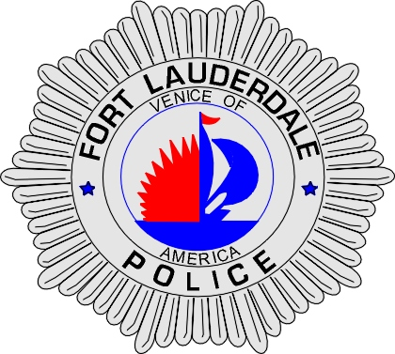 | CITY OF  FORT LAUDERDALE  POLICE DEPARTMENT  PRESS RELEASE
Sergeant Frank Sousa  Public Information Office  (954) 828-6433  FSousa@fortlauderdale.gov | CITY OF  FORT LAUDERDALE  POLICE DEPARTMENT  PRESS RELEASE | October 6, 2010
 | MISSING MALE

The Fort Lauderdale Police Department is requesting help from the public in locating a missing 85 year-old man.

Joseph Glenn Parncutt was last seen the afternoon of Tuesday, October 5, 2010. Parncutt was last seen at the Stain Glass Pub at approximately 4:00 P.M. Family members reported Parncutt missing as they are concerned with the fact that he had been depressed. Parncutt left his residence without his wallet, identification, or his vehicle. Parncutt does take medications for his heart, which he also does not have on his person.

Parncutt was last seen wearing light colored blue jeans, a red button down plaid shirt, and brown shoes. He is approximately 5’9”, 150 pounds, gray/blue eyes, and has short hair.

Anyone with information as to the whereabouts of this missing person is encouraged to contact the Fort Lauderdale Police Department or Detective Kathy Collins at 954-828-5548.


Joseph Parncutt

###

