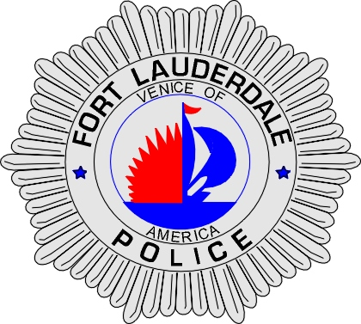 | CITY OF  FORT LAUDERDALE  POLICE DEPARTMENT  PRESS RELEASE
Sergeant Frank Sousa  Public Information Office  (954) 828-6433  FSousa@fortlauderdale.gov | CITY OF  FORT LAUDERDALE  POLICE DEPARTMENT  PRESS RELEASE | October 1, 2010
 | DUNKIN DONUTS ROBBERY
***VIDEO IS AVAILABLE***

The Fort Lauderdale Police Department is investigating an armed robbery that occurred at the Dunkin Donuts located at 1579 South Federal Highway. The robbery took place on September 28, 2010 at approximately 8:30 P.M.

Detectives have learned that the victim was in the back of the store cleaning up, when she heard the door buzzer sound. When the victim turned around, she observed two armed black males running towards her. The suspects demanded the money from the cash register. The clerk, in fear for her safety, handed over the money. The armed males then went to the rear of the store, where they unlocked the door and fled.

The first suspect has been described as a black male, in his twenties, and approximately 5’9”. He was last seen wearing a black jacket, black shorts, and black and red Air Jordan sneakers. The second suspect has been described as a black male, also in his twenties. He was last seen wearing a black hooded shirt with black pants.

Anyone with information regarding this armed robbery is encouraged to contact Detective Orlando Almanzar at 954-828-5546 or Broward County Crime Stoppers at 954-493-TIPS.

###

