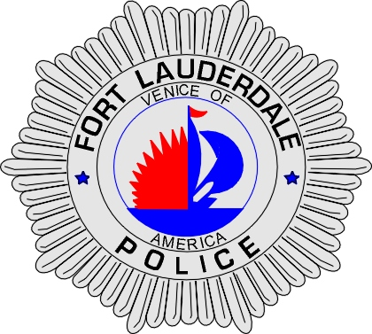 | CITY OF  FORT LAUDERDALE  POLICE DEPARTMENT  PRESS RELEASE
Sergeant Frank Sousa  Public Information Office  (954) 828-6433  FSousa@fortlauderdale.gov | CITY OF  FORT LAUDERDALE  POLICE DEPARTMENT  PRESS RELEASE | October 1, 2010
 | ARMED ROBBERY
***VIDEO IS AVAILABLE***

The Fort Lauderdale Police Department is investigating an armed robbery that occurred at American Scrap Metal on September 23, 2010. The robbery took place at approximately 4:52 P.M. American Scrap Metal is located at 824 Northwest 9 Avenue.

Preliminary investigation has revealed that a white male came to the scrap yard earlier on in the day inquiring as to the selling price of copper. The victim advised the male that he would have to see the copper and that if he was going to sell it back he would have to bring photo identification. A short time later the victim observed the same white male outside of the business. The white male advised that he was waiting for a truck to arrive so he could sell the copper back.

A short time later, the white male approached the victim in the parking lot and demanded money from him, while he was armed with a handgun. The victim in fear for his safety gave him what was in his pockets. The suspect then forced the male to take him inside of the business’s office. While inside of the office, the suspect demanded a money tray. The suspect took the money tray and then entered an unknown white two door vehicle with dark tint.

The suspect was last seen wearing a black hat, black sweat-shirt, brown pants, and work boots. The loss was approximately $800.00.

Anyone with information regarding this armed robbery is encouraged to contact Detective Elijah Thomas at 954-828-6093 or Broward County Crime Stoppers at 954-493-TIPS.





