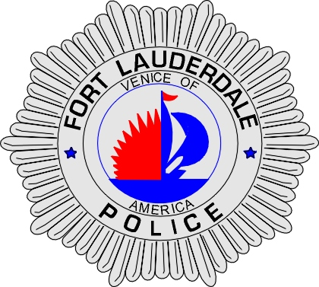 | CITY OF  FORT LAUDERDALE  POLICE DEPARTMENT  PRESS RELEASE
Sergeant Frank Sousa  Public Information Office  (954) 828-6433  FSousa@fortlauderdale.gov | CITY OF  FORT LAUDERDALE  POLICE DEPARTMENT  PRESS RELEASE | September 16, 2010
 | HOMICIDE

The Fort Lauderdale Police Department is investigating a homicide that occurred on Wednesday, September 15, 2010 at approximately 10:58 P.M. The homicide took place at 1315 Northwest 7 Street.

Investigators have learned the following information from interviewing various witnesses. The suspect and some acquaintances became involved in a verbal argument with the victim. The argument was over a disagreement between the victim and a woman over video games and some alcohol. The verbal argument escalated and the suspect, along with several friends, began to beat the victim. During the time the victim was being beat, he was also shot. The victim was transported to Broward General Medical Center where he was pronounced deceased.

The victim has been identified as Edison Austin, B/M, 10/01/1980.

The suspect has been identified as Quentin Pierce, B/M, 07/31/1986, and a Lauderhill resident.

Anyone with information regarding this homicide or who knows the whereabouts of the suspect is encouraged to contact Detective Mark Breen at 954-828-5708, Detective Jack DiCristofalo at 954-828-6096, or Broward County Crime Stoppers at 954-493-TIPS.
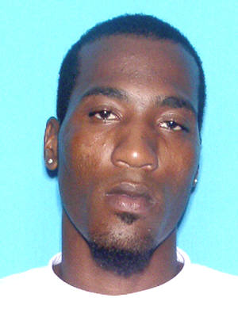
Quentin Pierce
###

