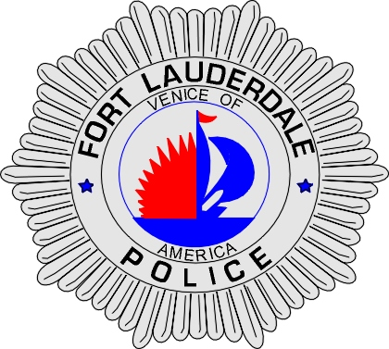 | CITY OF  FORT LAUDERDALE  POLICE DEPARTMENT  PRESS RELEASE
Sergeant Frank Sousa  Public Information Office  (954) 828-6433  FSousa@fortlauderdale.gov | CITY OF  FORT LAUDERDALE  POLICE DEPARTMENT  PRESS RELEASE | September 1, 2010
 | MISSING ELDERLY MALE

The Fort Lauderdale Police Department is investigating a missing elderly male. Police Dispatch received a telephone call from Harbor Beach Nursing and Rehab at approximately 5:40 P.M. The facility located at 1615 South Miami Road was housing Elijah Wilson. Elijah Wilson is a black male, 5’5”, 125 pounds, and he is 77 years old. He was last seen wearing a blue button down shirt and gray slacks.

The facility advised that Wilson left between the hours of 5:15 and 5:25 P.M. They have been unable to locate Wilson since that time. The staff has checked every room and surrounding areas of the facility. During a check of the facility, a staff member noticed one of the side doors was partially open.

Wilson suffers from Dementia and does not have the capability to get back to the facility on his own. Wilson is also on several medications. The police department has conducted a reverse 911 call back and has notified a Child is Missing.

This is not the first time that Wilson has gone missing. Wilson was recently reported missing from another facility and was ultimately located at Broward General Medical Center.

If anyone has any information on the whereabouts of Wilson they are encouraged to contact the Fort Lauderdale Police Department at 954-828-5700 or Broward County Crime Stoppers at 954-493-TIPS.

We do not have a photo of Wilson at this time. The facility is working on obtaining a digital copy for us. I will email it as soon as I have one. It is not anticipated until the morning.

###

