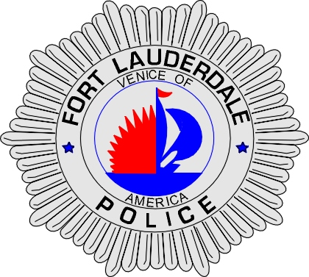 | CITY OF  FORT LAUDERDALE  POLICE DEPARTMENT  PRESS RELEASE
Sergeant Frank Sousa  Public Information Office  (954) 828-6433  FSousa@fortlauderdale.gov | CITY OF  FORT LAUDERDALE  POLICE DEPARTMENT  PRESS RELEASE | September 10, 2010
 | ATTEMPTED ARMED ROBBERY
***VIDEO IS AVAILABLE***

The Fort Lauderdale Police Department is investigating an attempted armed robbery that occurred on September 1, 2010 at approximately 9:00 P.M. The attempted armed robbery took place at Marina Discount Beverages located at 2705 Southwest 15th Avenue.

Detectives have learned that a white male suspect entered the store and retrieved a can of ice tea from the coolers. The suspect approached the register to pay for the ice tea. As he was attempting to pay for his ice tea, a second white male enters the store armed with a handgun. The unknown culprit points the gun at the cashier and demands money from the register. The cashier hesitated upon hearing the demand. The suspect became anxious and departed the store without retrieving any money.

The first suspect is described as a white male, between the ages of 16-18, and he was last seen wearing a black tee shirt and black shorts. This suspect was also armed with a handgun. The second suspect has been described as a white male, between the ages of 16-18, and he was last seen wearing a light colored shirt with black shorts.

Anyone with information regarding this attempted armed robbery or who knows the identities of the two suspects is encouraged to contact Detective Elijah Thomas at 828-6093 or Broward County Crime Stoppers at 954-493-TIPS.

###

