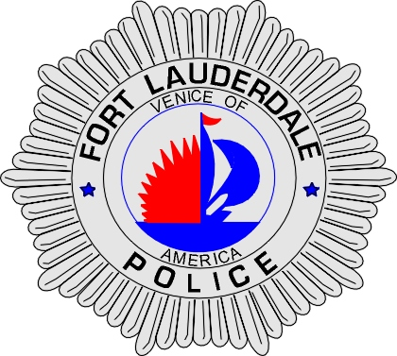 | CITY OF  FORT LAUDERDALE  POLICE DEPARTMENT  PRESS RELEASE
Sergeant Frank Sousa  Public Information Office  (954) 828-6433  FSousa@fortlauderdale.gov | CITY OF  FORT LAUDERDALE  POLICE DEPARTMENT  PRESS RELEASE | August 12, 2010
 | BUSINESS BURGLARIES

The Fort Lauderdale Police Department is investigating three separate business burglaries that have occurred over the last two days. The burglaries have occurred at 826 Northeast 1 Avenue in various bays. The impacted victims all specialize in car sales.

Detectives have discovered that the suspects have gained entry into the various bays and have been able to access the keys to various motor vehicles. One of the vehicles that were taken was used to smash the gate to the fenced in compound. In total, approximately 7 vehicles have been stolen. We have been able to recover 4 vehicles. Police are still actively seeking a Corvette, Jaguar, blue Kia Sorrento, gray Nissan Pathfinder, and approximately three dealer plates.

Police are seeking a group of white or Hispanic males in their twenties.

Anyone with information is encouraged to contact Detective Andy Mueller at 954-828-5577, Detective Tom Ferri at 954-828-5560, or Broward County Crimes Stoppers at 954-493-TIPS.





