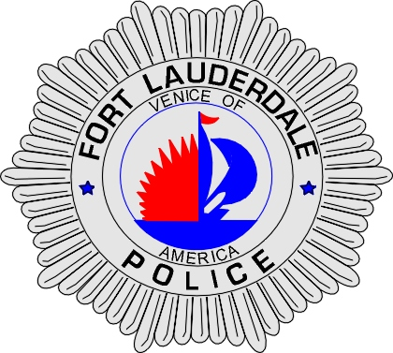 | CITY OF  FORT LAUDERDALE  POLICE DEPARTMENT  PRESS RELEASE
Sergeant Frank Sousa  Public Information Office  (954) 828-6433  FSousa@fortlauderdale.gov | CITY OF  FORT LAUDERDALE  POLICE DEPARTMENT  PRESS RELEASE | August 4, 2010
 | COP JAM

The Fort Lauderdale Police Department will be hosting an end of camp picnic for 130 students that participated in this year’s summer camp. The camp commonly known as Cop Jam was held from June 21st and concludes on Thursday, August 5, 2010. The camp participants ranged in ages from 10-16 years of age.

The camp was conducted by various School Resource Officer’s. These officers provided mentoring and a safe environment for the camp participants. The students were taught anti-gang and anti-drug curriculum. The camp also worked with at-risk students in an effort to guide them in the right direction. The officers also expanded their roles and met with local park officials to assess youth crime and truancy. The officers are scheduled to meet with the at-risk students and their parents to provide resources to stay on the correct track.

The Police Department invited members of the media to come and share in the end of camp luncheon. The luncheon will be held on Thursday, August 5, 2010 at 11:00 A.M. The luncheon will take place at New River Middle School by the gymnasium.

###

