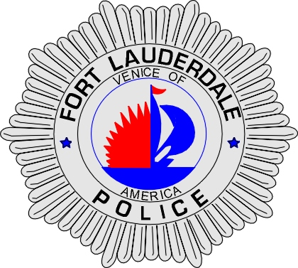 | CITY OF  FORT LAUDERDALE  POLICE DEPARTMENT  PRESS RELEASE
Sergeant Frank Sousa  Public Information Office  (954) 828-6433  FSousa@fortlauderdale.gov | CITY OF  FORT LAUDERDALE  POLICE DEPARTMENT  PRESS RELEASE | August 4, 2010
 | VIDEO VOYEURISM

The Fort Lauderdale Police Department arrested Jarrell Jarvis King, B/M, 5/3/1988 and a Fort Lauderdale resident. King has been charged with video voyeurism and tampering with evidence. King was employed by the Y.M.C.A as a group leader.

Detectives have learned that the victim was attending day camp at the Y.M.C.A located at 408 NW 14 Terrace. The victim went inside of the restroom and was followed in by the group leader King. The victim went into a bathroom stall and disrobed, sitting down on the toilet. King then reached over the stall and took photos of the victim against their will and permission.

King is responsible for the welfare of the victim, who was just 10 years old. King openly admitted to Y.M.C.A officials about taking the photo and he stated that he did so as a practical joke. King deleted the photos from his cell phone prior to police arrival.

If anyone has any information regarding this incident they are encouraged to contact Detective Lisa Cahir at 954-828-5964 or Broward County Crime Stoppers at 954-493-TIPS.

###

