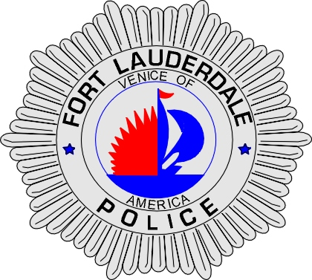 | CITY OF  FORT LAUDERDALE  POLICE DEPARTMENT  PRESS RELEASE
Sergeant Frank Sousa  Public Information Office  (954) 828-6433  FSousa@fortlauderdale.gov | CITY OF  FORT LAUDERDALE  POLICE DEPARTMENT  PRESS RELEASE | July 30, 2010
 | JOINT OPERATION

The Fort Lauderdale Police Street Crimes Unit has worked in conjunction with the Naval Criminal Investigative Service (NCIS) since Monday July 26, 2010 in an effort to combat street level narcotics sales and street level prostitution. The NCIS Agents are here on official business and are part of the USS Barry and the HMS Liverpool. The ships will be docked at Port everglades until Monday, August 2nd, 2010.

The NCIS conducts these joint operations in various ports throughout the world. They are used as force multipliers in adding additional law enforcement officers on the street.

The results of the joint operation were the following:
- 10 felony arrests
- 20 misdemeanor arrests
- 5 prostitution arrests
- A trafficking in Oxycodone arrest

###

