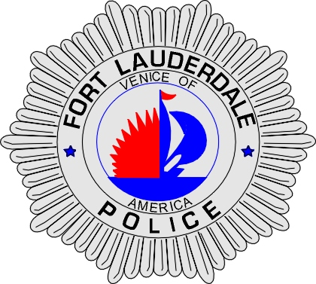 | CITY OF  FORT LAUDERDALE  POLICE DEPARTMENT  PRESS RELEASE
Sergeant Frank Sousa  Public Information Office  (954) 828-6433  FSousa@fortlauderdale.gov | CITY OF  FORT LAUDERDALE  POLICE DEPARTMENT  PRESS RELEASE | July 16, 2010
 | SEXUAL BATTERY

The Fort Lauderdale Police Department has arrested Kamonte Lemik McNeill and he has been charged with two counts of sexual battery and one count of battery.

Detectives received information from two separate victims that Kamonte, who was employed as a masseuse, at Massage Envy in Fort Lauderdale had sexually battered each of them. Both victims went to Massage Envy to receive massages. It was during those massages that Kamonte committed the sexual batteries.

These acts that were committed by Kamonte were done against each victim’s wishes. Kamonte is a Broward County resident and he was born on March 18, 1978.

Detectives believe that there may be more victims. Anyone with information regarding these cases or who may have been a victim is encouraged to contact Detective Lisa Cahir at 954-828-5964 or Broward County Crime Stoppers at 954-493-TIPS.



###

