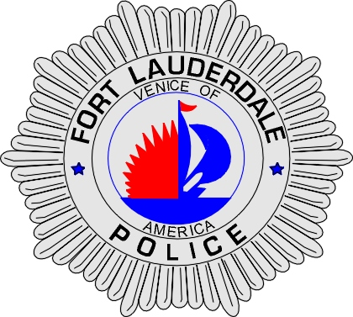 | CITY OF  FORT LAUDERDALE  POLICE DEPARTMENT  PRESS RELEASE
Detective Katherine Collins  Public Information Office  (954) 828-5548  KCollins@fortlauderdale.gov | CITY OF  FORT LAUDERDALE  POLICE DEPARTMENT  PRESS RELEASE | July 8, 2010
MAN CHARGED WITH
100 COUNTS
OF
CHILD PORNOGRAPHY

The Fort Lauderdale Police Department, a member of the South Florida Internet Crimes Against Children (ICAC) Taskforce has arrested Frank A. Richardson, 36, and charged him with 100 counts of Possession of Child Pornography and 1 count of Distribution of Child Pornography. The ICAC task force members involved in this operation were from the Fort Lauderdale Police Department, the Broward County Sheriff’s Office and Immigrations and Customs Enforcement (ICE).

During the months of April and May 2010, a computer with a Fort Lauderdale IP address was found sharing child pornography via the internet. The investigation revealed that the IP address resolved to Frank Richardson at 701 SW 18 Court, Fort Lauderdale. Detectives were also able to download approximately fifty (50) files directly from Richardson that were consistent with child pornography. A search warrant was obtained for the residence and at approximately 6:30pm Wednesday, the search warrant was executed at his residence. The search revealed over 100 child pornography movies/images located upon his computer. These images included children as young as 3 years old being sexually abused by adults. During a post-Miranda interview, the defendant gave a full confession to knowingly downloading and possessing child pornography.

Richardson has lived in the community most of his life and may have had contact with children. If anyone has information regarding Richardson, please contact Detective Robert Mauro at (954) 888-1570.




