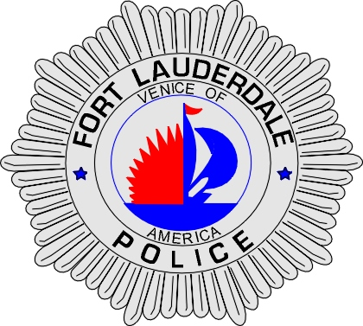 | CITY OF  FORT LAUDERDALE  POLICE DEPARTMENT  PRESS RELEASE
Sergeant Francis Sousa  Public Information Office  (954) 828-6643  Fsousa@fortlauderdale.gov | CITY OF  FORT LAUDERDALE  POLICE DEPARTMENT  PRESS RELEASE | July 9, 2010
 | CITY BEGINS WARNING PERIOD FOR PHOTO-ENFORCEMENT PROGRAM

Update:
As of August 2010, the City of Fort Lauderdale is using red light cameras at designated intersections throughout the city to deter red light runners and improve safety. A courtesy warning period has commenced and will continue throughout the month of August. Beginning September 2010, violators will be fined for failing to stop at steady red lights. This violation is a state authorized fine and violators face a $158.00 fine for each offense.

Original:
The City of Fort Lauderdale's red-light photo-enforcement program will begin issuing Notices of Violation to red-light runners at designated intersections beginning August 8, 2010. The cameras are being installed as part of the City's effort to use technology to deter red light runners.

During a six-year period, between 2004 and 2009, traffic crashes occurring at signal controlled intersections in the City of Fort Lauderdale resulted in 26 fatalities. Red-light accidents often are among the worst because they generally involve vehicles crashing directly into the driver or passenger side of another vehicle at high speeds.

The photo-enforcement cameras are scheduled for installation at the following intersections:
- N. Federal Highway at N.E. 8th Street
- N.E. 15th Avenue at E. Sunrise Boulevard
- S.R. 84 at S.W. 9th Avenue
- W. Sunrise Boulevard at N.W. 15th Avenue
- W. Commercial Boulevard at N.W. 21st Avenue
- S. Federal Highway at S.R. 84
- N.W. 62nd Street at N.W. 9th Avenue
- W. Commercial Boulevard at N.W. 9th Avenue
- N.W. 62nd Street at N.W. 31st Avenue

Cameras will operate 24-hours a day and capture images of every vehicle running a red light at the intersection. Warning signs will alert drivers to the red-light cameras.

The Mark Wandall Traffic Safety Program was passed by the Florida Legislature and approved by the Governor on May 13, 2010. The new law, effective July 1, 2010, includes the following components:

(more)
- Authorizes the Department of Highway Safety and Motor Vehicles, a county, or a municipality to use a traffic infraction detector to identify a motor vehicle that fails to stop at a traffic control signal steady red light;

- Requires authorization of a traffic infraction enforcement officer to issue and enforce a citation for such violation;
- Establishes a fine of $158 for a violation of s. 316.074(1) or s. 316.075(1)(c)1 when a driver has failed to stop at a traffic signal if enforcement is by a county or municipal traffic infraction enforcement officer;
- Requires notification to be sent to the registered owner of the motor vehicle involved in the violation;
- A county or municipality may use traffic infraction detectors to enforce Florida State Statutes 316.074(1) or 316.075(1)(c)1 when a driver fails to stop at a traffic signal on streets and highways under their jurisdiction under state statute 316.0083.
- The owner of the motor vehicle involved in the violation is responsible and liable for paying the uniform traffic citation issued for a violation of s. 316.074(1) or s.316.075(1)(c)1 when the driver failed to stop at a traffic signal, unless the owner can establish the following:
a. The motor vehicle passed through the intersection in order to yield right-of-way to an emergency vehicle or as part of a funeral procession;
b. The motor vehicle passed through the intersection at the direction of a law enforcement officer;
c. The motor vehicle was, at the time of the violation, in the care, custody, or control of another person; or,
d. A uniform traffic citation was issued by a law enforcement officer to the driver of the motor vehicle for the alleged violation of s. 316.074(1) or s.316.075(1)(c)1.

American Traffic Solutions, Inc., was contracted by the City of Fort Lauderdale to administer the program. Each violation will be reviewed and approved by the Fort Lauderdale Police Department prior to a citation being issued.

For more information about the red-light enforcement program, visit www.FLPD.org.

###

