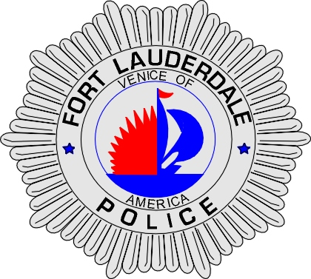 | CITY OF  FORT LAUDERDALE  POLICE DEPARTMENT  PRESS RELEASE
Sergeant Frank Sousa  Public Information Office  (954) 828-6433  FSousa@fortlauderdale.gov | CITY OF  FORT LAUDERDALE  POLICE DEPARTMENT  PRESS RELEASE | July 1, 2010
 | FUGITIVE ARRESTED

The Fort Lauderdale Police Department is proud to announce the arrest of Scott Thorpe. Members of the Fort Lauderdale Fugitive Unit and members of the United States Marshall Service (USMS) Florida Fugitive Task Force Unit arrested Thorpe today.

The USMS Florida Fugitive Task Force, which includes Fort Lauderdale Detectives, received information that Thorpe was believed to be in Fort Lauderdale and that he was possibly homeless. Thorpe was wanted on warrants for Attempted Homicide, Kidnapping, and several other felony charges. The USMS Florida Fugitive Task Force began surveillance throughout the City of Fort Lauderdale, as well as contacting several social service agencies.

On July 1st, 2010, members of the Fort Lauderdale Fugitive Unit and the USMS Florida Fugitive Task Force observed Thorpe in the 900 block of North Andrews Avenue. A perimeter was established with the assistance of Fort Lauderdale Patrol Officers. Thorpe was taken into custody as he exited the residence at 622 Northeast 1 Avenue.

Thorpe will be extradited to Washington County, New York to face charges. Scott Thorpe is a W/M and his birthday is 6/16/1972.

###

