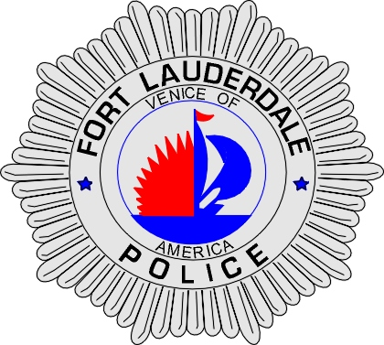 | CITY OF  FORT LAUDERDALE  POLICE DEPARTMENT  PRESS RELEASE
Detective Katherine Collins  Public Information Office  (954) 828-5548  KCollins@fortlauderdale.gov | CITY OF  FORT LAUDERDALE  POLICE DEPARTMENT  PRESS RELEASE | July 7, 2010
FLPD EARNS PRESTIGIOUS
RE-ACCREDITATION

On July 1, 2010, Chief Franklin C. Adderley and the Staff Inspections Unit from the Fort Lauderdale Police Department appeared before the Commission for Florida Law Enforcement Accreditation (C.F.A.) where the Department earned the prestigious status of re-accreditation.

The Fort Lauderdale Police Department first earned the status of being accredited in 1998 by C.F.A. The accreditation certificate was valid for three years and the agency reached re-accreditation in 2001, 2004 and 2007. In order to maintain the professional standard for another three years, the Department had to undergo a reassessment to demonstrate adherence to the highest State law enforcement standards and policies.
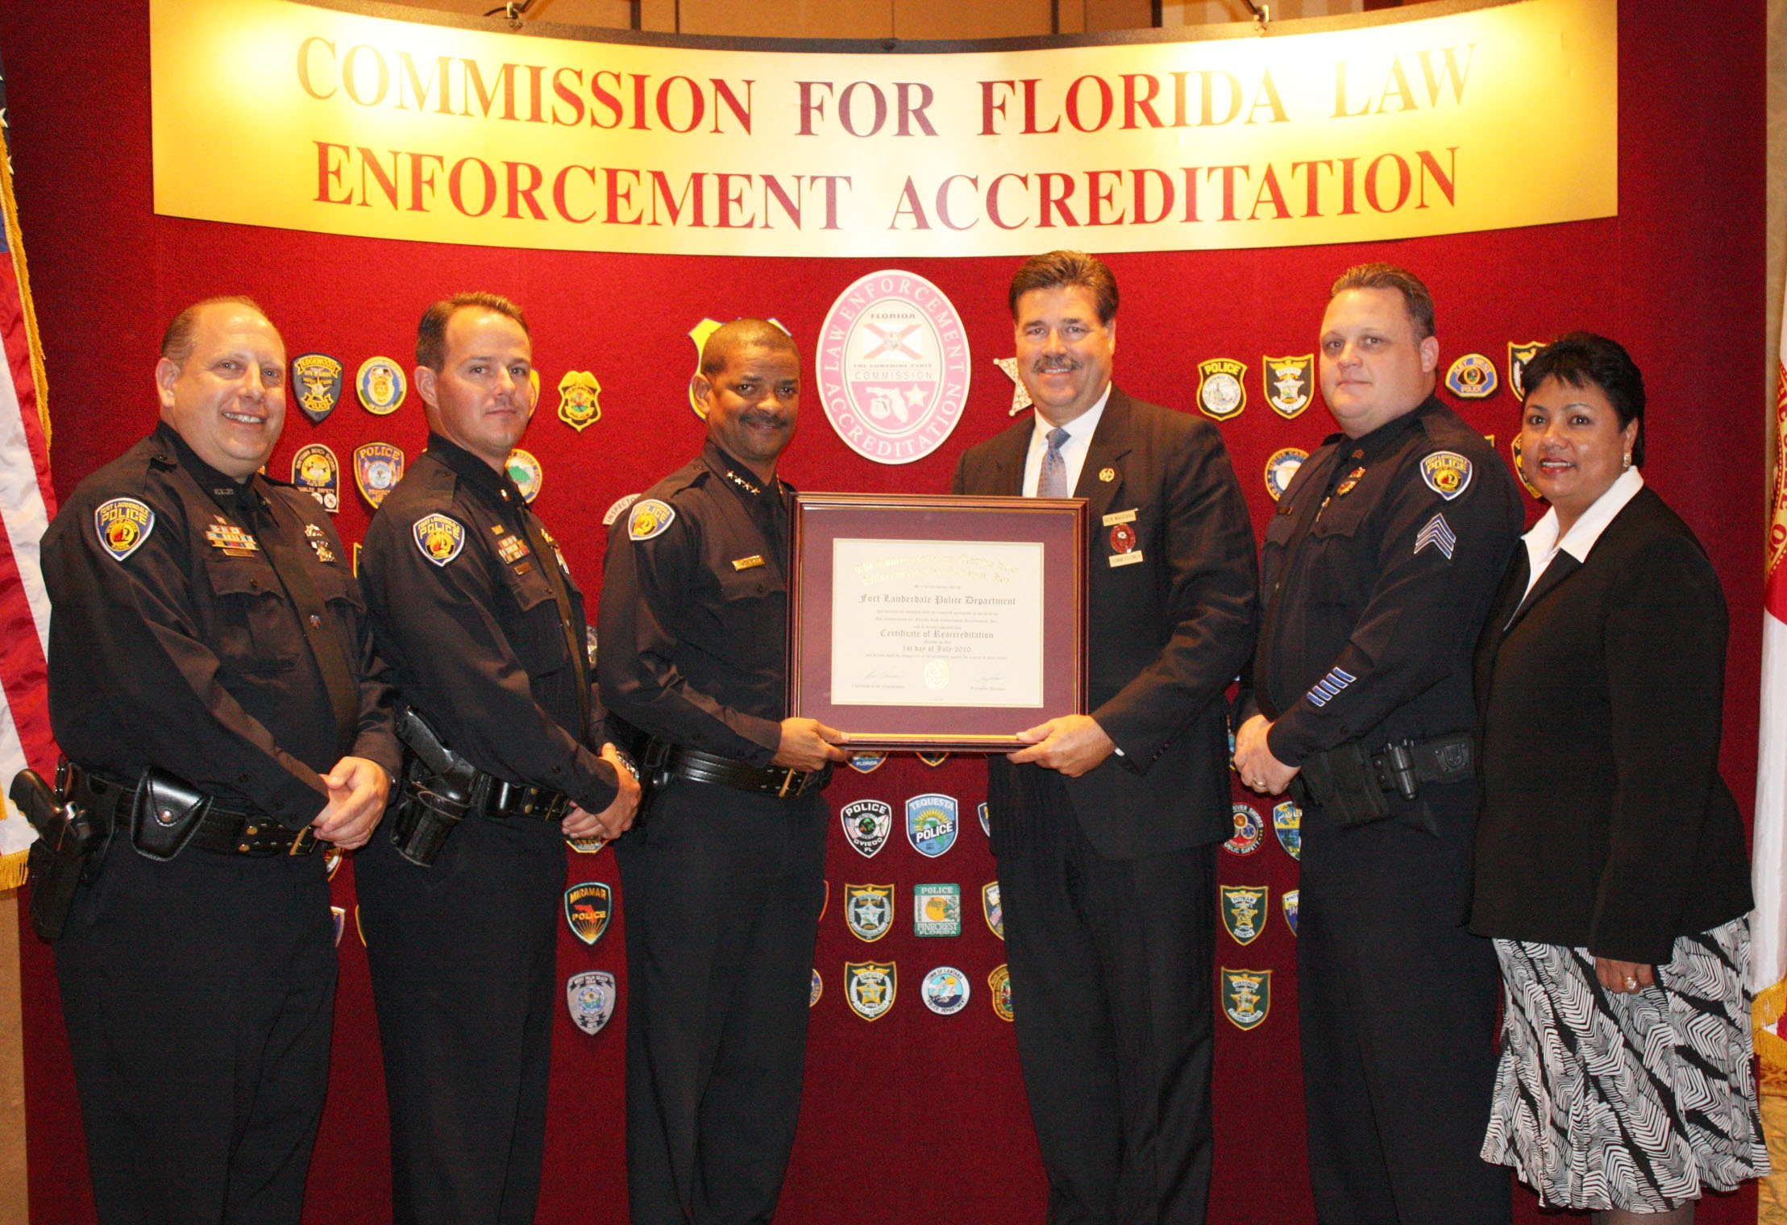

Pictured L to R: Detective Allen Lerner, Lieutenant Patrick Hart,
Fort Lauderdale Police Chief Franklin C. Adderley, Commissioner
and Sheriff Ken Mascara of the Saint Lucie Sheriff’s Office,
Sergeant Joel Winfrey and Administrative Assistant Farida Mohammed.

The Staff Inspections Unit, made up of Lieutenant Patrick Hart, Sergeant Joel Winfrey, Detective Allan Lerner and Administrative Assistant Farida Mohammed,

(more)

prepared a three-year plan in order to ensure compliance of mandatory and non-mandatory standards through internal audits and inspections, policy reviews and revisions and file maintenance. The plan had to be precise in order to reach the end result of re-accreditation and was tested on March 9th, 2010 when the Commission sent three assessors to the Fort Lauderdale Police Department to conduct the re-accreditation on-site assessment.

Department personnel were thoroughly prepared for this inspection which lasted three days and focused on all aspects of the agency. The assessors examined all of the files and confirmed compliance by conducting interviews and observing various areas of the Department. The prevailing theme discovered by the assessment team was the mutual feeling of pride, dedication, loyalty and the strong sense of Fort Lauderdale tradition.

###

