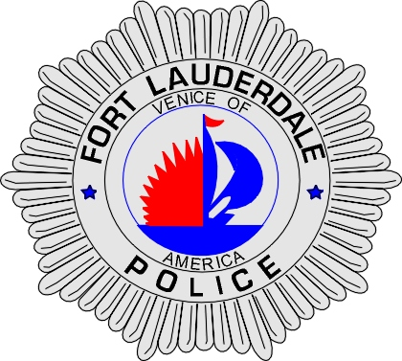 | CITY OF  FORT LAUDERDALE  POLICE DEPARTMENT  PRESS RELEASE
Sergeant Frank Sousa  Public Information Office  (954) 828-6433  FSousa@fortlauderdale.gov | CITY OF  FORT LAUDERDALE  POLICE DEPARTMENT  PRESS RELEASE | June 29, 2010
 | ARMED ABDUCTION

Update 1:
The Fort Lauderdale Police Department has made an arrest in conjunction with the armed abduction. Information was developed today and Detectives were able to locate and charge Fabian Douglas with Kidnapping and Attempted Sexual Battery. Fabian Douglas is a Lauderhill resident and was born on January 1st, 1986.

Original:
The Fort Lauderdale Police Department is investigating an armed abduction that occurred on June 16th, 2010. The abduction took place in the 1800 block of Northwest 6 Street at approximately 10 P.M.

Investigators have learned that the victim was waiting for a bus at the bus stop when she was confronted by an armed black male. The suspect, who was driving a light colored, 4-door mid-size vehicle, pulled alongside the victim. The suspect ordered the victim inside of his vehicle at gunpoint. The victim complied with the suspects demands and entered the vehicle.

The suspect drove the victim to a nearby location and while holding her at gunpoint, he demanded that she have sex with him. The victim, fearing for her life, decided to take a chance at being harmed and attempted to escape the vehicle. The victim was able to escape and call the police to report what had occurred.

The victim was injured during this encounter and did receive medical treatment for her injuries.

The suspect has been described as a black male, mid-to-late twenties, approximately 5’10”, stocky build, and approximately 180 pounds. He was last seen wearing a black tee shirt and had an earring on.

The initial investigation has led to Detectives identifying a person of interest. It is this person that police are seeking assistance in identifying. If anyone has any information on the identity of this person we ask that they please contact Detective Mark Shotwell at 954-828-5517 or Broward County Crime Stoppers at 954-493-TIPS.





