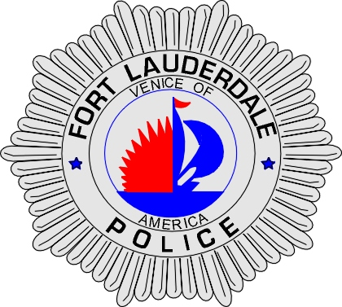 | CITY OF  FORT LAUDERDALE  POLICE DEPARTMENT  PRESS RELEASE
Sergeant Frank Sousa  Public Information Office  (954) 828-6433  FSousa@fortlauderdale.gov | CITY OF  FORT LAUDERDALE  POLICE DEPARTMENT  PRESS RELEASE | June 25, 2007
 | WEAPONS COMPLAINT

Fort Lauderdale Patrol Officers responded to 545 Southwest 18th Avenue, #34 on June 24th, 2010 at approximately 10:22 P.M. Officers were dispatched to that location upon receiving information that shots had been fired.

Upon arrival, officers heard gunshots coming from the location and established a perimeter. Contact was made with John Haurin, W/M, 2/18/1971. Haurin advised that he had been shot and that his roommate was inside of the residence with the shooter. Haurin was examined and it was discovered that he was not shot and that a bullet had grazed his foot. Based on the information provided, an S.W.A.T call-out was initiated, and a perimeter was established for the safety of the residents in the area.

Investigators have learned that Michael Nunn, W/M, 8/15/1965 had been in his bedroom all day, without exiting. Nunn’s three roommates were getting ready to go out for the evening when they heard several shots being fired. The shots penetrated the drywall in the residence. Flying debris struck Richard Genna in the back and rounds pierced Tony Sirago, W/M, 1/27/1977 in his upper leg area. Neither of the victims injuries are life threatening.

Genna and Haurin were able to exit the residence. Sirago was able to lock himself in a bedroom until S.W.A.T was able to rescue him. After a period of negotiation, Dunn surrendered himself to members of the S.W.A.T team.

Dunn was transported to Broward Genera Medical Center, where he was admitted for medical evaluation.

Based on the investigation, it does not appear that Nunn targeted any of the victims. All three victims were interviewed and declined to press charges.

Anyone with information regarding this matter is encouraged to contact the Fort Lauderdale Police Department at 954-828-5700 or Broward County crime Stoppers at 954-493-TIPS.
###

