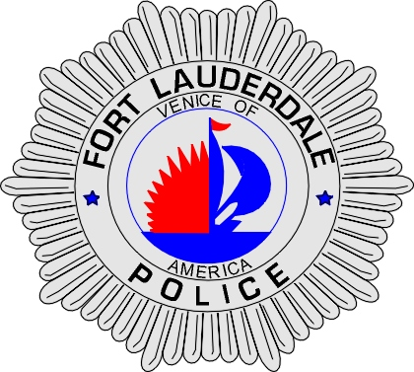 | CITY OF  FORT LAUDERDALE  POLICE DEPARTMENT  PRESS RELEASE
Sergeant Frank Sousa  Public Information Office  (954) 828-6433  FSousa@fortlauderdale.gov | CITY OF  FORT LAUDERDALE  POLICE DEPARTMENT  PRESS RELEASE | June 23, 2010
 | TRAFFIC FATALITY

Update:
The deceased has been identified as Roberto Leiva, W/M, 10/14/1987, and a Fort Lauderdale resident.

Original:
The Fort Lauderdale Police Department is investigating a Traffic fatality that occurred on Tuesday, June 22nd, 2010 at approximately 8:24 P.M. The accident occurred at SE 3rd Avenue and Davie Boulevard.

Traffic Homicide Investigators have learned that a 2010 Jeep Grand Cherokee was traveling eastbound on Davie Boulevard and attempted to make a left turn onto Southeast 3rd Avenue. A 2008 KNRO Scooter was traveling west on Davie Boulevard continuing straight through the intersection. The two vehicles collided. The collision caused the driver of the scooter to be thrown off of it and onto the pavement. The driver was transported to Broward General Medical Center where he was pronounced deceased.

At this time, the identity of the deceased is being held until proper notification is made to the family.

Anyone with information regarding this fatality is encouraged to contact Traffic Homicide Investigator Cindy Love at 954-828-5755 or Broward County Crime Stoppers at 954-493-TIPS.

###

