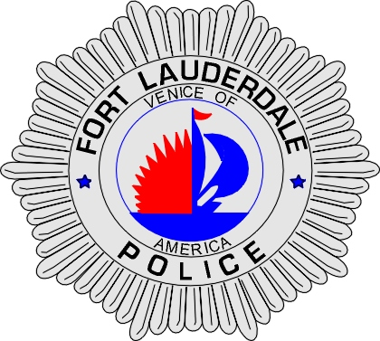 | CITY OF  FORT LAUDERDALE  POLICE DEPARTMENT  PRESS RELEASE
Sergeant Frank Sousa  Public Information Office  (954) 828-6433  FSousa@fortlauderdale.gov | CITY OF  FORT LAUDERDALE  POLICE DEPARTMENT  PRESS RELEASE | May 25, 2010
SUSPICOUS INCIDENT
(Person of Interest)
**VIDEO IS AVAILABLE**

The Fort Lauderdale Police Department is investigating a suspicious incident that occurred on March 27th, 2010. The incident took place at 1905 North Ocean Boulevard between the hours of 2:00 A.M. and 5:00 A.M.

Police are investigating the disappearance of several items from this location. These items include a Toshiba Laptop Computer, A Rolex watch, a Chanel watch, two diamond necklaces, and 2 diamond rings. The value of all of these items is in excess of $35,000.00

Detectives have learned that a white male met the victim at a parking garage in downtown Fort Lauderdale. The male was captured on video surveillance exiting the building where the victim lives. Police are seeking this person of interest to determine their involvement, if any, in this suspicious incident.

Anyone with information is encouraged to contact Detective Anthony Gnisci at 828-5967 or Broward County crime Stoppers.

###

