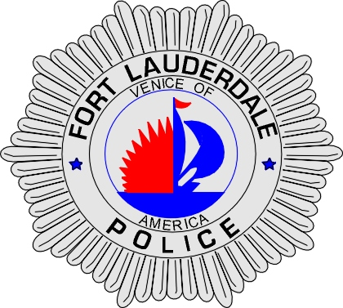 | CITY OF  FORT LAUDERDALE  POLICE DEPARTMENT  PRESS RELEASE
Detective Katherine Collins  Public Information Office  (954) 828-5548  KCollins@fortlauderdale.gov | CITY OF  FORT LAUDERDALE  POLICE DEPARTMENT  PRESS RELEASE | May 28, 2010
 | OFFICER INVOLVED CRASH

The Fort Lauderdale Police Department is investigating a single-vehicle crash involving a Fort Lauderdale police officer. The incident took place today at approximately 3:34pm in the intersection of W. Davie Boulevard and SW 4th Avenue.

The officer did sustain injuries but his official condition is not yet known.

PIO Kathy Collins will be at W. Davie Boulevard and SW 4th Avenue in the southeast corner at 4:45pm.

###

