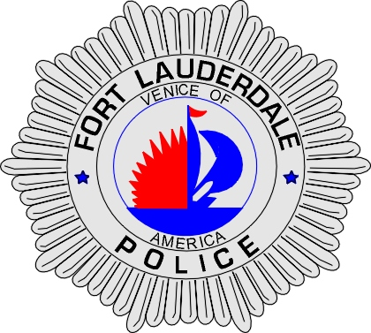 | CITY OF  FORT LAUDERDALE  POLICE DEPARTMENT  PRESS RELEASE
Detective Katherine Collins  Public Information Office  (954) 828-6433  KCollins@fortlauderdale.gov | CITY OF  FORT LAUDERDALE  POLICE DEPARTMENT  PRESS RELEASE | May 13, 2010
 | PRESS CONFERENCE

The Fort Lauderdale Police Department will have a press conference today, May 13, 2010, at 5:30pm at the Fort Lauderdale Police Department located at 1300 West Broward Boulevard.

This will be regarding the arrest of a Fort Lauderdale police officer.

If you have any questions, please contact Detective Kathy Collins at 954-828-6433.

###

