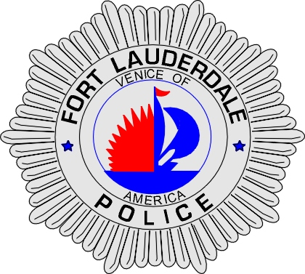 | CITY OF  FORT LAUDERDALE  POLICE DEPARTMENT  PRESS RELEASE
Detective Katherine Collins  Public Information Office  (954) 828-5548  KCollins@fortlauderdale.gov | CITY OF  FORT LAUDERDALE  POLICE DEPARTMENT  PRESS RELEASE | May 5, 2010
FORT LAUDERDALE
POLICE MEMORIAL

On Friday, May 7, 2009 beginning at 1:30 pm the Fort Lauderdale Fraternal Order of Police No. 31 will be honoring 12 Fort Lauderdale Police Officers who have been killed in the line of duty.

The event will be taking place at the Fort Lauderdale Police Memorial in the Esplanade Park in front of the Broward Center for the Performing Arts located at 500 SW 2nd Street, Fort Lauderdale.

The service will run approximately 30 minutes.

Following is a list of these 12 officers:

R. DWIGHT JOHNSTON, died in the line of duty as a result of a motorcycle accident, April 5, 1947

DONALD E. KIRBY, JR., died as a result of injuries sustained in a motorcycle accident, October 9, 1968

D. WALTER ILYANKOFF, was murdered by four culprits during an armed robbery of a local restaurant, July 21, 1974

GREGORY J. CONNERS, died in the line of duty as a result of a motorcycle accident, November 12, 1977

JOHN C. ALEXANDER, killed in a police airplane crash in the line of duty, August 3, 1981

KENNETH PETERSEN, killed in a police airplane crash in the line of duty, August 3, 1981

(more)

CHARLES E. BRUCE, died as a result of injuries sustained in a motorcycle accident, August 24, 1983

FRANK A. MASTRANGELO, killed in a police airplane crash in the line of duty, May 25, 1989

NORMAN EDDY, killed in a police airplane crash in the line of duty, May 25, 1989

DAVID L. BROWER, died as a result of injuries sustained in a motorcycle accident, December 29, 1994

BRYANT H. PENEY, was murdered while investigating a person acting in a suspicious manner, January 6, 1996

JOSE A. DIAZ, dies as a result of injuries sustained in a fall, October 8, 2005

For additional information contact FOP President Jack Lokeinsky (954) 527-2606.

###

