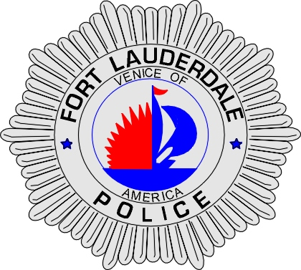 | CITY OF  FORT LAUDERDALE  POLICE DEPARTMENT  PRESS RELEASE
Detective Katherine Collins  Public Information Office  (954) 828-5548  KCollins@fortlauderdale.gov | CITY OF  FORT LAUDERDALE  POLICE DEPARTMENT  PRESS RELEASE | May 5, 2010
BROWARD COUNTY
LAW ENFORCEMENT
MEMORIAL DAY

The City of Fort Lauderdale Police Department will host this year’s Broward County Law Enforcement Memorial Day on Friday, May 7, 2010 at 7:00pm at the Institute of Public Safety in Davie, FL.

Broward County law enforcement agencies will honor officers who sacrificed their lives to ensure the safety and protection of the citizens of Broward County.

This solemn ceremony will include the posting of colors and presentation of arms by the Multi-Agency Honor Guard, wreath laying, candlelight vigil and a flyover.

Friday, May 7, 2010 at 7:00pm
Institute of Public Safety
Broward College
3501 Davie Road
Davie, Florida

Please contact Sergeant Frank Sousa at 954-445-1604 with any questions.

###

