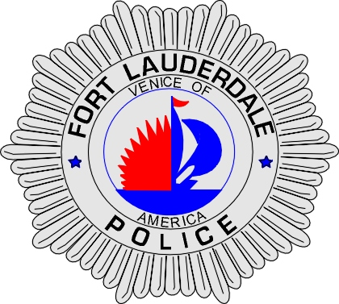 | CITY OF  FORT LAUDERDALE  POLICE DEPARTMENT  PRESS RELEASE
Detective Katherine Collins  Public Information Office  (954) 828-5548  KCollins@fortlauderdale.gov | CITY OF  FORT LAUDERDALE  POLICE DEPARTMENT  PRESS RELEASE | May 7, 2010
HOUSE FIRE
(Officers Rescue Man)

Today at approximately 3:00am, a neighbor of 729 SW 15th Avenue called 911 reporting a house was on fire. While fire-rescue was enroute, Fort Lauderdale police officers responded to the residence and arrived first. As smoke and flames were bellowing from the residence, three officers saw a man inside. They broke a window, gained entry and brought the man to safety. During the rescue, the man indicated to the officers that he wanted to die and in fact used dangerous chemicals to start the fire.

Fort Lauderdale fire-rescue extinguished the fire at the residence and of a nearby vehicle. A large dog was also pulled from the fire but was dead at the scene.

The man, who is in his 50s, was transported to Broward General Medical Center where he is listed in critical condition. The three officers who may have been exposed to chemicals were also brought to the hospital for precautionary reasons. At this time they appear to be uninjured.

Arson investigators with the fire and police departments are on scene to determine the exact cause of the fire.

###

