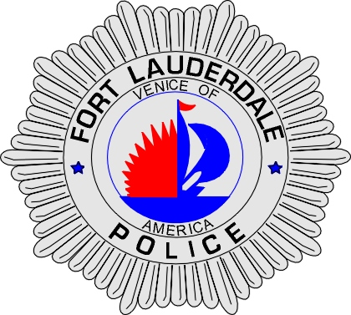 | CITY OF  FORT LAUDERDALE  POLICE DEPARTMENT  PRESS RELEASE
Sergeant Frank Sousa  Public Information Office  (954) 828-6433  FSousa@fortlauderdale.gov | CITY OF  FORT LAUDERDALE  POLICE DEPARTMENT  PRESS RELEASE | May 9, 2010
 | HOMICIDE

The Fort Lauderdale Police Department is investigating a homicide that occurred on Saturday, May 8, 2010 at approximately 12:07 A.M. The homicide took place at 1340 Northeast 5 Terrace inside of Middle River Terrace Park.

The Police Department received a telephone call from a passerby stating that they had heard shots fired inside of the park. Patrol officers responded and discovered a male who had been shot. The male was pronounced deceased at the park.

An autopsy was conducted by the Broward County Medical Examiners Office and this death has been ruled a homicide. The deceased has been identified as Willie Charles Henry, B/M, 9/26/1981, and a Fort Lauderdale resident.

Anyone with information or who may have witnessed this homicide is encouraged to contact Detective Jim Jaggers at 954-828-5970, Detective Mark Shotwell at 954-828-5517, or Broward County Crime Stoppers at 954-493-TIPS.

###

