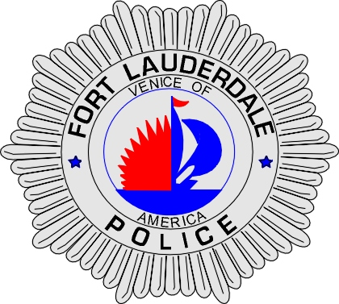 | CITY OF  FORT LAUDERDALE  POLICE DEPARTMENT  PRESS RELEASE
Sergeant Frank Sousa  Public Information Office  (954) 828-6433  FSousa@fortlauderdale.gov | CITY OF  FORT LAUDERDALE  POLICE DEPARTMENT  PRESS RELEASE | May 9, 2010
 | HOMICIDE

Update:
Subsequent to the release of information that this was an accidental death, investigators began receiving information from witnesses that this death may be a homicide. Investigators were able to locate and interview witnesses, who corroborated that this was a homicide. Detectives contacted the Medical Examiner’s Office on Sunday and advised them of their new leads in this case. The ruling of the death was then changed to an undetermined death, pending additional information.

Investigators were able to identify two possible suspects and began to circulate the City in search of them. Investigators learned that the victim, Bradly Schmidt, was involved in a verbal dispute with the two suspects over monetary matters. The dispute turned physical and the two suspects struck the victim several times in the head, back, and groin. As a result of these strikes, the victim fell to the ground, where he ultimately passed away from his injuries.

The suspects have been taken into custody and have been identified as Jimmy D. Graviett, W/M, 3/14/1971 and Robert Michael Gallant, W/M, 10/8/1977. They have both been charged with 2nd Degree Murder. The Medical Examiner’s Office has declared this case a homicide.

Original:
The Fort Lauderdale Police Department is investigating an accidental death that occurred on Saturday, May 9, 2010. The death took place at 115 South Andrews Avenue at approximately 10:38 P.M.

The Police Department received information from a caller that there was an unconscious male lying on the sidewalk next to the Government Center Building. Patrol Officers responded and discovered the male, who was deceased.

The Broward County Medical Examiners Office conducted an autopsy this morning and the death was ruled accidental. The victim has been identified as Bradly Michael Schmidt, W/M, 8/22/1964, and a homeless male.

Investigators have discovered that Schmidt suffered from multiple medical ailments, which contributed to his death.

This investigation is on going and anyone with information is encouraged to contact Detective William DeJesus at 954-828-5366 or Broward County Crime Stoppers at 954-493-TIPS.

###

