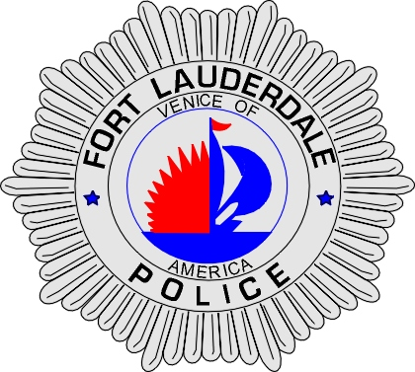 | CITY OF  FORT LAUDERDALE  POLICE DEPARTMENT  PRESS RELEASE
Sergeant Frank Sousa  Public Information Office  (954) 828-6433  FSousa@fortlauderdale.gov | CITY OF  FORT LAUDERDALE  POLICE DEPARTMENT  PRESS RELEASE | April 28, 2010
 | ARMED ROBBERY
***VIDEO IS AVAILABLE***

The Fort Lauderdale Police Department is investigating an armed robbery that occurred on Thursday, April 15, 2010 at approximately 8:28 P.M. The robbery took place at the Stop & Save Market located at 1505 Southwest 20 Street.

Mohammed Hossain, W/M, 2/15/1979, and a Hollywood resident called police advising that he had just been held up at the market. Hossain advised police that while he was working, a black male 18-20 years of age, rode a bicycle to the store and left it outside. A few moments later, the suspect walked into the store with a black tee-shirt wrapped around his head as a mask. The suspect then pointed a black gun at Hossain demanding money from the register. In fear for his safety and his life, Hossain handed over the money from the cash register. The suspect then fled the store and left on his bicycle.

Fort Lauderdale Police Officers circulated the store in search of the suspect but were unable to locate him. The suspect was further described as being approximately 5’6” and 145 pounds.

Anyone with information or who may have witnessed this robbery is encouraged to contact Detective Tracy Figone at 954-828-5518 or Broward County Crime Stoppers at 954-493-TIPS.




