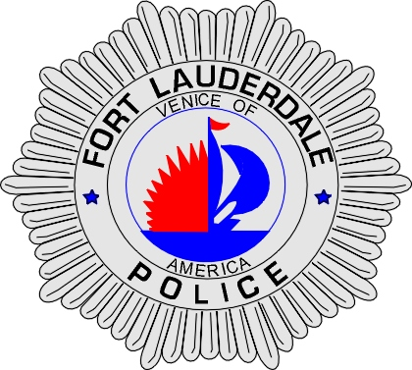 | CITY OF  FORT LAUDERDALE  POLICE DEPARTMENT  PRESS RELEASE
Sergeant Frank Sousa  Public Information Office  (954) 828-6433  FSousa@fortlauderdale.gov | CITY OF  FORT LAUDERDALE  POLICE DEPARTMENT  PRESS RELEASE | April 12, 2010
 | TRAFFIC HOMICIDE INVESTIGATION

The Fort Lauderdale Police Department is investigating a vehicle versus pedestrian accident that occurred on Sunday, April 11th, 2010 at approximately 8:24 P.M. The accident took place at the 4000 block of North Ocean Boulevard.

Traffic Homicide investigators have learned that Armando Jose-Namis was driving a 2010 Mazda CX-7 northbound on North Ocean Boulevard in the 4000 block. Andrew Natoli was running eastbound across the northbound lanes of North Ocean Boulevard in the 4000 block. The right front portion of Jose-Namis’ vehicle struck Natoli.

Natoli was transported to Broward General Medical Center with life threatening injuries.

The investigation into this accident continues. Anyone with information or who may have witnessed this accident is encouraged to contact Traffic Homicide Investigator Jill Hirsch at 954-828-5753 or Broward County Crime Stoppers at 954-493-TIPS.

###

