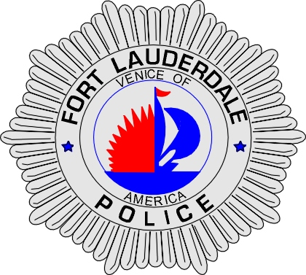 | CITY OF  FORT LAUDERDALE  POLICE DEPARTMENT  PRESS RELEASE
Sergeant Frank Sousa  Public Information Office  (954) 828-6433  FSousa@fortlauderdale.gov | CITY OF  FORT LAUDERDALE  POLICE DEPARTMENT  PRESS RELEASE | April 12, 2010
SEXUAL PREDATOR ARRESTED
(Possibly more Victims)
***PHOTO ON PAGE 2***

The Fort Lauderdale Police Department in conjunction with the South Florida Internet Crimes Against Children (ICAC) Task Force executed a search warrant on Friday, April 9th, 2010. Members of the Task Force include the Fort Lauderdale Police Department, Broward Sheriff’s Office, U.S. Immigrations and Customs Enforcement (ICE), the Attorney General’s Office, and the United States Secret Service.

Detectives from the Fort Lauderdale Police Department developed an IP address during an undercover internet investigation that had downloaded over 80 files depicting child pornography. The investigation revealed an address in Lauderhill and a suspect. The suspect was identified as Christopher Thornton, B/M, 04/17/1982.

Fort Lauderdale Detectives and members of ICAC Task Force executed the search warrant at Thornton’s residence. The warrant yielded one computer with over 80 movies and images depicting children between the ages of 4 and 12 engaged in sexual activity. Additionally, obscene images of two unreported child victims were located upon the computer.

Thornton was arrested and charged with twenty five (25) counts of Possession of Child Pornography and 1 count Production of Child Pornography. Post Miranda, Thornton advised investigators that he was a tutor and a football coach and that he utilized his positions to access children and that he molested two children for nearly 3 years. Thornton also produced child pornography by photographing the genitals of these children and made it available for distribution on the internet.

2 child victims have been identified in Delray Beach, Florida and New York. Authorities are currently working on interviewing these victims and additional charges are pending.

Investigators and members of the ICAC Task Force fear that there may be additional victims. If anyone recognizes Thornton, and may have been victimized by him, they are encouraged to contact Detective Rob Mauro at 954-828-6871 or Broward County Crime Stoppers at 954-493-TIPS.

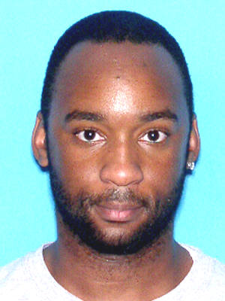
Christopher Thornton

###

