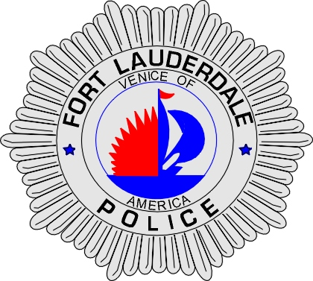 | CITY OF  FORT LAUDERDALE  POLICE DEPARTMENT  PRESS RELEASE
Sergeant Frank Sousa  Public Information Office  (954) 828-6433  FSousa@fortlauderdale.gov | CITY OF  FORT LAUDERDALE  POLICE DEPARTMENT  PRESS RELEASE | April 1, 2010
 | TRAFFIC FATALITY

The Fort Lauderdale Police Department is investigating a traffic fatality that occurred on Wednesday, March 31, 2010 at approximately 12:45 P.M. The accident took place at 111 East Las Olas Boulevard.

Traffic Homicide investigators have learned the following: a 2007 GMC truck was being driven by Michael Kornahrens northbound on Southeast 2nd Avenue. The victim, Douglas Deboer was southbound across East Las Olas Boulevard in the 100 block. Kornahrens made a left turn to westbound East Las Olas Boulevard, striking Deboer.

Deboer was trauma alerted to Broward General Medical Center with life threatening injuries. Deboer passed away at 5:36 P.M. as a result of his injuries.

The investigation into this fatal accident continues and anyone with information is encouraged to contact Traffic Homicide Investigator Donald Goedke at 954-828-5754 or Broward County Crime Stoppers at 954-493-TIPS.

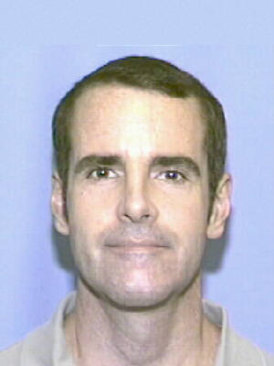
Douglas Deboer

###

