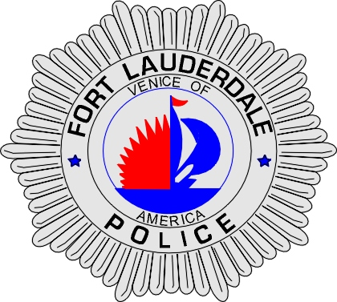 | CITY OF  FORT LAUDERDALE  POLICE DEPARTMENT  PRESS RELEASE
Sergeant Frank Sousa  Public Information Office  (954) 828-6433  FSousa@fortlauderdale.gov | CITY OF  FORT LAUDERDALE  POLICE DEPARTMENT  PRESS RELEASE | March 24, 2010
 | UNLAWFUL SEXUAL ACTIVITY

The Fort Lauderdale Police Department was made aware of unlawful sexual activity that was occurring between a minor and her track coach at Hollywood Christian Academy on Tuesday, March 23, 2010. Detectives responded and contacted school officials, as well as the victims and their parents.

Detectives have learned that Raymond Holmes entered into a sexual relationship with the victim, who he coached. Detectives have learned that they engaged in a sexual relationship at least three times. Detectives also discovered that David Tillman assisted his family member with coaching the track team voluntarily. On March 19, 2010, Tillman also had sex with another victim who is also a student at Hollywood Christian Academy.

Parents discovered the sexual relationship and alerted school authorities, who then notified the Police Department. The parents of both victims do desire prosecution.

Raymond Holmes was arrested and charged with Unlawful Sexual Activity with certain Minors and David Tillman was charged with Lewd or Lascivious Battery.

The investigation into this crime continues. Anyone with any additional information is encouraged to contact Detective Lisa Cahir at 954-828-5964, Detective Innocent-Doles at 954-828-5137, or Broward County Crime Stoppers at 954-493-TIPS.
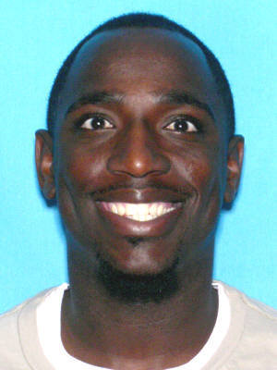
Raymond Holmes
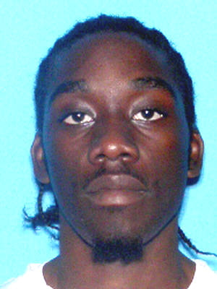
David Tillman

###

