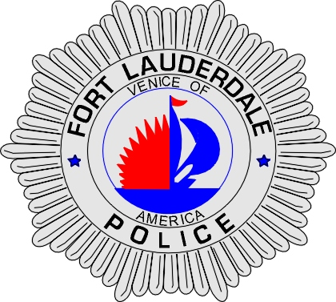 | CITY OF  FORT LAUDERDALE  POLICE DEPARTMENT  PRESS RELEASE
Sergeant Frank Sousa  Public Information Office  (954) 828-6433  FSousa@fortlauderdale.gov | CITY OF  FORT LAUDERDALE  POLICE DEPARTMENT  PRESS RELEASE | December 17, 2009
 | Homicide

Update:

The victim of this homicide has been identified as Linda Cain Chestnut, B/F, 04/30/1961. The investigation is still on-going.

Original:
The Fort Lauderdale Police Department received a phone call at approximately 7:13 A.M. this morning about a body being located at 201 Northwest 20th Avenue.

Police and Fire responded to the location and confirmed that they had a deceased person. This is an active homicide investigation that is currently being worked by Fort Lauderdale Homicide and Crime Scene Investigation Detectives. An Autopsy has been tentatively scheduled for tomorrow.

The victim, a black female, described as being approximately 40-50 years of age, was found wearing denim jeans with red stitching and a beige tank-top.

Anyone with information regarding this homicide is encouraged to contact Detective Mark Shotwell at 954-828-5517, Detective Jim Jaggers at 954-828-5970, or Broward County crime Stoppers at 954-493-TIPS.

###

