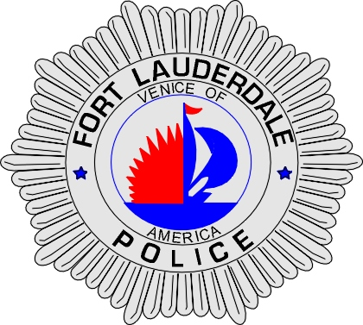 | CITY OF  FORT LAUDERDALE  POLICE DEPARTMENT  PRESS RELEASE
Sergeant Frank Sousa  Public Information Office  (954) 828-6433  FSousa@fortlauderdale.gov | CITY OF  FORT LAUDERDALE  POLICE DEPARTMENT  PRESS RELEASE | December 17, 2009
 | TRAFFIC CHECKPOINT

The Fort Lauderdale Police Department will be conducting a traffic safety checkpoint on Friday, December 18, 2009. The location of the checkpoint will be in the 400-700 block of Northwest 13 Street. The checkpoint will be conducted from 10:00 A.M. until 3:00 P.M.

Vehicles will be randomly selected and drivers will be checked for valid paperwork and driver’s license. Officers will also be conducting safety inspections on checked vehicles. The police department does not anticipate any traffic delays because of this operation.

###

