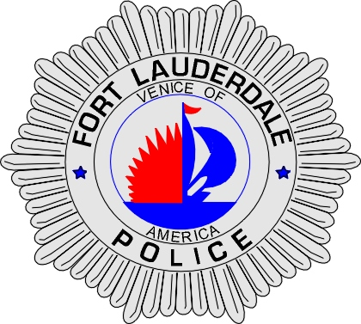 | CITY OF  FORT LAUDERDALE  POLICE DEPARTMENT  PRESS RELEASE
Sergeant Frank Sousa  Public Information Office  (954) 828-6433  FSousa@fortlauderdale.gov | CITY OF  FORT LAUDERDALE  POLICE DEPARTMENT  PRESS RELEASE | December 31, 2009
 | DROWNING

Update 2:
On Friday, January 8, 2010, Fort Lauderdale Police Homicide Detectives made an arrest in connection with this drowning. Billy Tyner, W/M, 11/6/1962 was charged with one count of Manslaughter.

Update 1:
The male that entered the New River has been identified as Robert Lee Merritt, W/M, 8/23/1981, a Fort Lauderdale resident. This case is currently being handled as an unknown death and the investigation into what occurred is on-going.

Original:
The Fort Lauderdale Police Department received reports of a male drowning at approximately 10:48 P.M. The drowning took place in the area of 10 South New River Drive East.

Preliminary investigation has revealed that a male entered the New River at the above location and has not been seen since then. Fort Lauderdale Police Dive Rescue Unit responded and worked a search of the river all night. At this time, no body has been recovered. Dive Units will continue searching the river this morning.

Investigators are looking into allegations that the male may have been pushed into the New River. The Homicide Unit is actively working this case and the investigation continues.

Anyone with information regarding this incident is encouraged to contact Detective Jack DiCristofalo at 954-828-6096, Detective William DeJesus at 954-828-5366, or Broward County Crime Stoppers at 954-493-TIPS.

###

