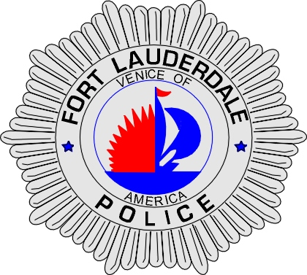 | CITY OF  FORT LAUDERDALE  POLICE DEPARTMENT  PRESS RELEASE
Sergeant Frank Sousa  Public Information Office  (954) 828-6433  FSousa@fortlauderdale.gov | CITY OF  FORT LAUDERDALE  POLICE DEPARTMENT  PRESS RELEASE | December 10, 2009
 | HOMICIDE

The Fort Lauderdale Police Department is investigating a homicide that occurred on Wednesday, December 9, 2009 at approximately 1:15 P.M. The homicide took place at 1139 Northwest 9 Avenue, Fort Lauderdale.

Preliminary investigation has revealed that the victim Eva Mae Hills, B/F, 10/13/1957, arrived at the suspect’s residence with another individual. The suspect became angry and an argument ensued. The verbal argument escalated and the suspect shot Hills. Hills was transported to Broward General Medical Center where she was pronounced deceased.

The suspect was detained on scene and brought to the police station. The suspect was ultimately charged with 2nd Degree Murder. The suspect has been identified as Forrest Hughley, B/M, 2/4/1939.

Anyone with information regarding this homicide is encouraged to contact Detective Mark Breen at 954-828-5708, Detective Jack DiCristofalo at 954-828-6096, or Broward County Crime Stoppers at 954-493-TIPS.

###

