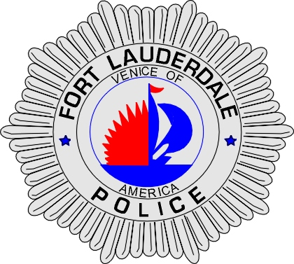 | CITY OF  FORT LAUDERDALE  POLICE DEPARTMENT  PRESS RELEASE
Sergeant Frank Sousa  Public Information Office  (954) 828-6433  FSousa@fortlauderdale.gov | CITY OF  FORT LAUDERDALE  POLICE DEPARTMENT  PRESS RELEASE | December 10, 2009
 | SEXUAL BATTERY

The Fort Lauderdale Police Department is investigating a Sexual Battery that occurred early this morning. The attack occurred in the area of Northwest 3 Avenue between Broward Boulevard and Sunrise Boulevard.

Investigation has revealed that the suspect smashed out a window to the victim’s vehicle in order to burglarize it. Upon hearing the car alarm, the victim went to investigate why her alarm was ringing. When the victim opened the door to where she was located she was grabbed by the defendant and the sexual battery occurred.

The suspect fled the area and was located by a Fort Lauderdale Police Officer. Police conducted a show-up and positively identified the culprit. The suspect has been identified as Javerros Wright, B/M, 1/15/1987.

Wright has been charged with Sexual Battery; Burglary with Battery; Burglary Conveyance; Strong-arm Robbery; and Kidnapping.

The investigation continues. Anyone with information regarding this sexual battery is encouraged to contact Broward County Crime Stoppers at 954-493-TIPS.

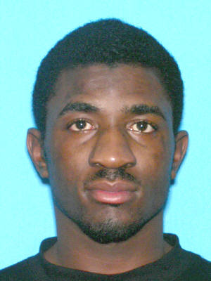
Javerros Wright

###

