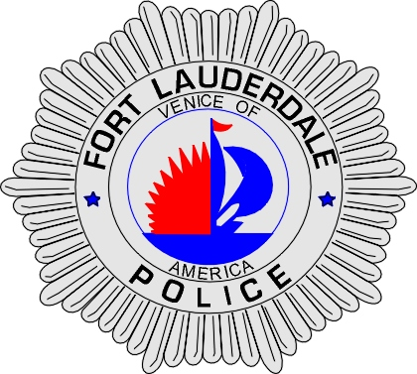 | CITY OF  FORT LAUDERDALE  POLICE DEPARTMENT  PRESS RELEASE
Sergeant Frank Sousa  Public Information Office  (954) 828-6433  FSousa@fortlauderdale.gov | CITY OF  FORT LAUDERDALE  POLICE DEPARTMENT  PRESS RELEASE | December 11, 2009
 | HOMICIDE FUGITIVE CAUGHT AFTER 9 ½ Years

The Fort Lauderdale Police Department is pleased to announce the arrest of a homicide fugitive, who had been on the run for approximately 9 ½ years. The fugitive, Yakoub Levy, was wanted in connection with a homicide that occurred on 2/4/2000.

For several years, there has been a cooperative effort amongst many law enforcement agencies to capture Levy. Members of the Fort Lauderdale Police Fugitive squad along with the FBI Fugitive Task Force, United States Marshall Service, and Immigration and Customs Enforcement have worked tirelessly to ensure that Levy is brought to justice.

The homicide in question occurred at 2217 Northwest 8 Street. Officials were able to arrest two other suspects in connection with this homicide. Investigators have worked several leads to locate Levy. Information was developed that Levy was in Jamaica and a joint effort ensued to bring Levy back to South Florida to face his charges. Finally on Thursday, December 10, 2009, Levy arrived back in Fort Lauderdale where he was taken into custody.

The effort of all agencies involved is remarkable and has not only led to a violent fugitive being taken into custody but it also provides additional closure for the victim’s family.

###

