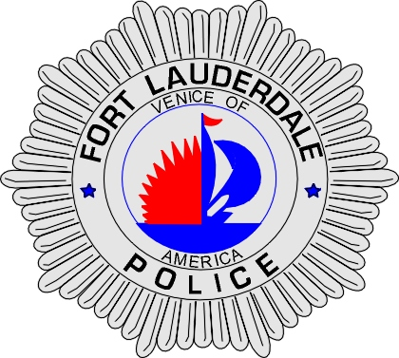 | CITY OF  FORT LAUDERDALE  POLICE DEPARTMENT  PRESS RELEASE
Sergeant Frank Sousa  Public Information Office  (954) 828-6433  FSousa@fortlauderdale.gov | CITY OF  FORT LAUDERDALE  POLICE DEPARTMENT  PRESS RELEASE | December 14, 2009
 | CARBON MONOXIDE POISONING

The Fort Lauderdale Police Department is investigating a carbon monoxide poisoning call, which resulted in two young children being hospitalized.

The police department received a call at approximately 8:00 A.M. this morning from Plantation Police Department advising that they had two children hospitalized at Plantation General. We were advised us that the children were admitted to the hospital by their father. The father has been identified as Derek Frazier, B/M, 6/20/1973. The incident location where the exposure to carbon monoxide occurred was at 1614 Northwest 16 Court.

Fort Lauderdale Police and Fire Rescue responded to the residence and secured it. Investigators have discovered that the family had been unemployed for a period of time. As a result of this, their electricity was disconnected. The father stated to investigators that he would utilize a generator during the day to keep the refrigerator and home cool. The father also advised us that he would shut off the generator upon the children and family arriving at the residence. He stated that the windows were always open to air out the residence.

Early this morning the father discovered the two children unresponsive and he transported them to Plantation General on his own. The two children have been admitted to the hospital and are currently in critical condition, but are expected to survive. The rest of the family was also checked out at the hospital.

Investigators continue to gather evidence that is involved in this case. Children Protective Services have been notified and the State Attorney will ultimately decide if charges are filed. The case continues.

Anyone with information regarding this incident is encouraged to contact the Fort Lauderdale Police Department at 954-828-5700 or Broward County Crime Stoppers at 954-493-TIPS.
###

