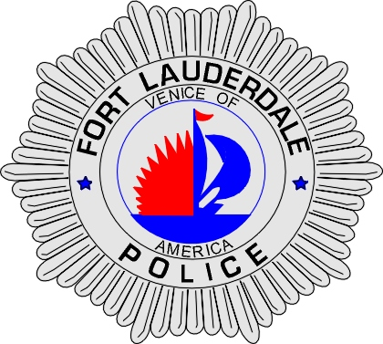 | CITY OF  FORT LAUDERDALE  POLICE DEPARTMENT  PRESS RELEASE
Sergeant Frank Sousa  Public Information Office  (954) 828-6433  FSousa@fortlauderdale.gov | CITY OF  FORT LAUDERDALE  POLICE DEPARTMENT  PRESS RELEASE | December 3, 2009
 | TRAFFIC FATALITY

Update:

The victim of this traffic fatality has been identified as John Douglas Russell a Fort Lauderdale Resident.

Original:
The Fort Lauderdale Police Department is investigating a traffic fatality that occurred on Wednesday, December 2, 2009 at approximately 4:30 P.M. The accident took place at Northeast 18 Avenue and East Commercial Boulevard.

Preliminary investigation has revealed that vehicle one, a 1998 Ford Taurus, was stopped southbound in the right turn lane of Northeast 18 Avenue. Vehicle two, a pedacyclist, was stopped on the northwest corner sidewalk. The pedacyclist entered into East Commercial Boulevard in a southbound direction, where the pedacyclist fell to the pavement. The Taurus proceeded with a right turn onto East Commercial Boulevard and ran over the pedacyclist, who was still on the ground. The driver of the Taurus remained on the scene. The pedacyclist was transported to North Broward Hospital where he was later pronounced deceased.

The identity of the victim is being held until proper notification is made to their family.

Anyone with information regarding this accident is encouraged to contact the Fort Lauderdale Police Department at 954-828-5700 or Broward County Crime Stoppers at 954-493-TIPS.

###

