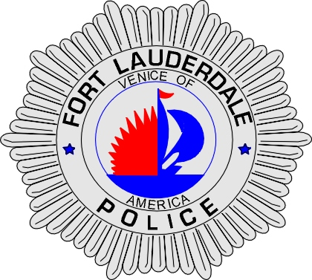 | CITY OF  FORT LAUDERDALE  POLICE DEPARTMENT  PRESS RELEASE
Sergeant Frank Sousa  Public Information Office  (954) 828-6433  FSousa@fortlauderdale.gov | CITY OF  FORT LAUDERDALE  POLICE DEPARTMENT  PRESS RELEASE | December 7, 2009
 | TRAFFIC FATALITY

The Fort Lauderdale Police Department is investigating a traffic fatality that occurred on Saturday, December 5, 2009. The accident took place in the 2100 block of East Commercial Boulevard.

Preliminary investigation has revealed that a motorcycle was traveling eastbound in the 2100 block of East Commercial Boulevard. The operator of the motorcycle failed to negotiate a curve in the roadway, causing him to collide with the concrete curb on the south side of the roadway’s edge. The motorcycle continued onto the property of Bank of America (4901 North Federal Highway), where it collided with the concrete curb at the driveway’s edge. The driver of the motorcycle was ejected. The motorcycle and the driver came to rest in the shrubbery on that property.

The victim was deceased upon police arrival to the accident scene. The victim has been identified as Jason Walsh, W/M, 24 years of age, and a Pompano Beach resident.

Anyone with information regarding this accident or anyone who may have witnessed it is encouraged to contact Fort Lauderdale Police Traffic Homicide Investigator Cindy Love at 954-828-5755 or Broward County Crime Stoppers at 954-493-TIPS.

###

