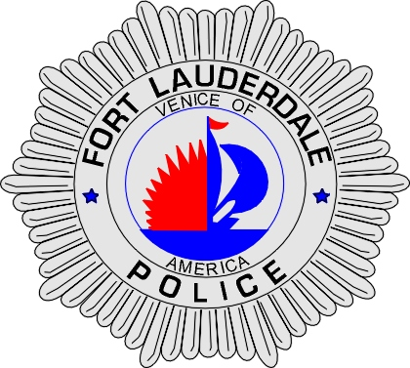 | CITY OF  FORT LAUDERDALE  POLICE DEPARTMENT  PRESS RELEASE
Sergeant Frank Sousa  Public Information Office  (954) 828-6433  FSousa@fortlauderdale.gov | CITY OF  FORT LAUDERDALE  POLICE DEPARTMENT  PRESS RELEASE | December 8, 2009
 | TRAFFIC CRASH

The Fort Lauderdale Police Department is investigating a traffic crash that occurred on Monday, December 7, 2009 at approximately 8:30 P.M. The crash took place at the 3200 block of North Ocean Boulevard.

Preliminary investigation has revealed that a 2008 Verucci Scooter entered the north bound lanes of North Ocean Boulevard from Northeast 32 Street. A 2006 Acura was traveling north on North Ocean Boulevard when the scooter entered its path of travel. The two vehicles collided, which caused the driver of the scooter to be ejected. The driver of the scooter landed on the pavement suffering from life threatening injuries. The male was transported to Broward General Medical Center where he is in critical condition.

The driver of the scooter has been identified as Richard Musho, W/M, and a Fort Lauderdale resident.

Anyone with information regarding this crash or who may have witnessed it is encouraged to contact Traffic Homicide Investigator Cindy Love at 954-828-5755 or Broward County Crime Stoppers at 954-493-TIPS.

###

