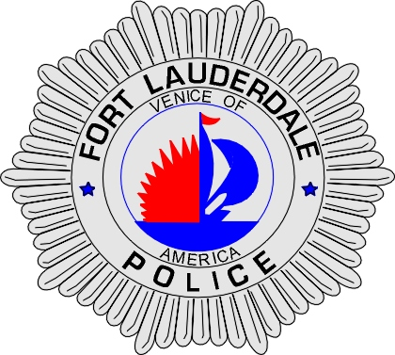 | CITY OF  FORT LAUDERDALE  POLICE DEPARTMENT  PRESS RELEASE
Sergeant Frank Sousa  Public Information Office  (954) 828-6433  FSousa@fortlauderdale.gov | CITY OF  FORT LAUDERDALE  POLICE DEPARTMENT  PRESS RELEASE | November 13, 2009
 | BANK OF AMERICA ROBBERY

On Friday, November 13, 2009 at approximately 10:15 A.M., an identified male robbed the Bank of America located at 4901 North Federal Highway, Fort Lauderdale, Florida.

According to detectives, the suspect entered the bank wearing blue jeans and a purple sweatshirt. The suspect approached the bank teller with a note and demanded money. The teller complied with the request and turned over the cash to the suspect.

The male fled the bank on foot and bank management immediately notified the police department. A B.O.L.O. was broadcast over police radio describing the suspect. Fort Lauderdale Police Officers began to circulate the area and an officer located a possible suspect a block away. The suspect was detained and a show-up was conducted. The bank employee was able to positively identify the culprit as the person who robbed the bank.

The culprit has been identified as Clayton M. Sheldon, W/M, 10/10/1958. He will be charged with one count of Strong-Arm Robbery.

At this time the investigation is on-going. Anyone with information in regards to this case is encouraged to contact Detective Elijah Thomas at 954-828-6093 or Broward County Crime Stoppers at 954-493-TIPS.

Clayton Sheldon
###

